**Lab 4: Design Half Adder & Full Adder Using Half Adder**

**Question 1: Write Verilog code for half adder. Test using waveform**

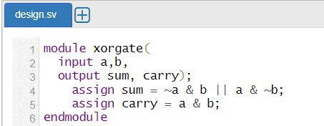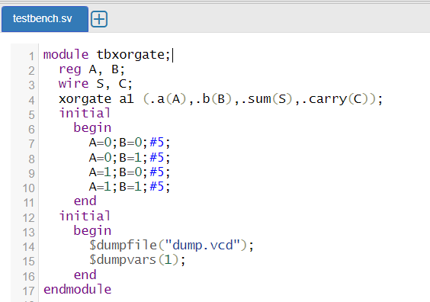



**Question 3. Write Verilog code for full adder. Test using waveform.**

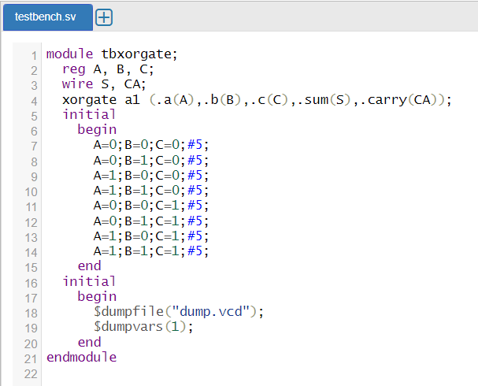

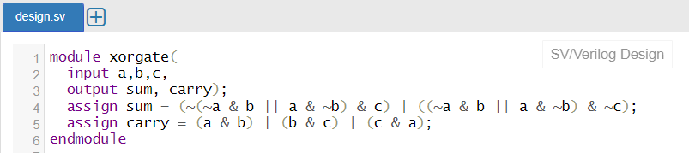



**Question 4. Write Verilog code for full adder using module instantiation of half adder. Test using waveform.**

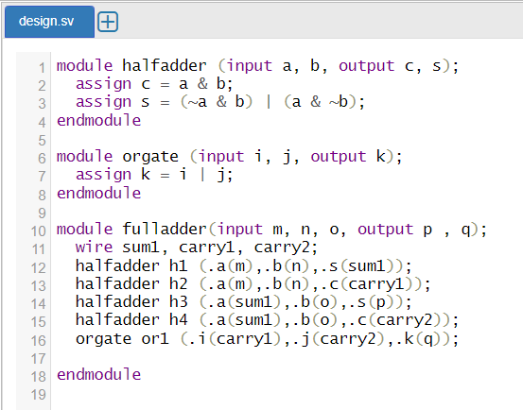

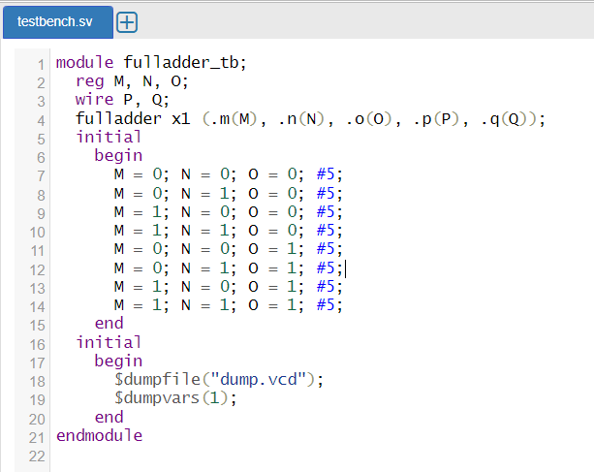



**Question 5. Write Verilog code for half adder using only NAND gate. Test using waveform**



